Product Requirements Document (PRD)
Product Title: Catastrophic Wildfire Prevention Consortium (CWPC) Platform
Feature Focus: Donation Feature for CWPC Website
Version: 1
Product Manager: Chukwufunaya Okpah

Executive Summary
The Donation feature’s aim to design a secure, user-friendly payment gateway for users and empower these users to make financial contributions easily and transparently. It aims to increase donor engagement by providing flexible, secure, and emotionally resonant donation options. This aligns with CWPC’s broader mission of wildfire prevention and community support

1.1 Problem Statement
While many users express interest in supporting CWPC’s mission, the current platform lacks a structured, compelling, and seamless way to accept donations. Users either get redirected or abandon the flow due to lack of payment flexibility, transparency, or impact visibility.

1.12 Users struggle to:
- Set up and manage recurring donations without needing to repeat the process every time.
- Receive prompt acknowledgment or receipts for their donations for personal or tax purposes.
- Find a transparent and trustworthy way to contribute financially online.
- Navigate complicated or lengthy donation forms that discourage them mid-process.
- Make donations via their preferred payment method (bank transfer, mobile wallet, USSD).

1.1.3 Value Proposition
This product offers a seamless bridge between investors, innovators, improving users through proactive and collaborative engagement, also providing valuable insights for other users. By choosing this product, user can
- Makes donating easy, secure, and emotionally resonant for all types of users.
- Offers multiple payment options that are accessible to both local and international donors.
- Provides real-time feedback on donation progress (e.g., a campaign meter or goal tracker).
- Encourages recurring giving through simple toggle options and flexible frequencies.
- Delivers a clear, impactful narrative showing how donations directly support wildfire prevention.
- Enables users to view and manage their donations through a personalized dashboard (post-MVP).
- Offers mobile-first design and integrates seamlessly with existing login and user flow.

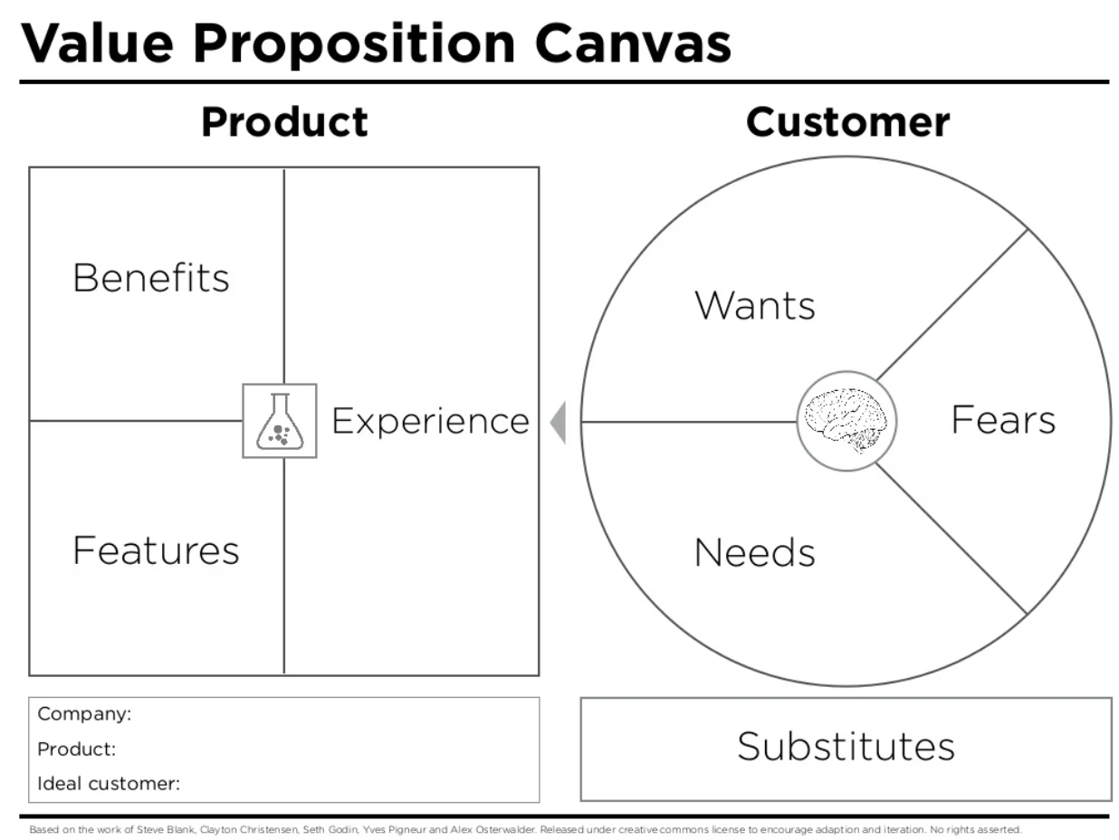

1.2 Goals & Objectives
Business Objectives
- Increase donation conversions by 40% within 3 months post-launch.
- Encourage recurring donations from at least 25% of donors.
- Improve credibility and trust through transparency and testimonials.
- Gaining support for our mission.
User Objectives
- Allow donors to contribute using preferred payment methods with minimal friction.
- Provide assurance on how their donations are used (impact).
- Offer both one-time and recurring donation options.

1.3 User Persona
- Investors
- Contributors
- Corporate Society Responsibility Bodies
- Communities - People that are affected
- Fire councils
- Fire fighters

1.4. Deliverables
MVP
- Donation Flow interface
- Payment Gateway Integration
- Impact Feedback Layer
- Transactional System
- Admin Dashboard (Lite)
- Security Layer
- Donation Page (Standalone + Embedded Widget)

2. Features Board
Feature | Description
Donate Button (Always Visible) | Present in top nav and donation-related sections
One-Time / Recurring Options | Users can choose between a single donation or monthly/quarterly contribution
Payment Methods | Card, Bank Transfer, PayPal, USSD, Mobile Wallet
Secure Checkout | HTTPS-enabled form with PCI-compliant payment gateway
Testimonials | Show real stories (video or quotes) from previous donations
Receipt & Thank You Email | Auto-generated email with amount, tax info, and acknowledgment

3. User Stories and Acceptance Criteria
Segment |  | User Story | Acceptance Criteria
Donation Entry Point | Donate Button | As a user, I want to easily find where to donate so I can support CWPC | A Donate button is visible in the navigation bar and on key landing pages. The user flow should not take more than 3 steps or less even.
 |  | As a returning user, I want a shortcut to donate again. | Authenticated users can access a quick donation link or use saved preferences
Donation Form | Amount Selection | As a user, I want to choose a preset or custom amount to donate | Form includes preset tiers (₦1,000, ₦5,000, ₦10,000) + custom field
 | Frequency Option | As a donor, I want to choose between a one-time or recurring donation. | Donation form includes toggle for donation frequency
 | Payment Options | As a donor, I want to use my preferred payment method. | Users can pay via card, mobile wallet, USSD, or bank transfer
Payment Processing | Secure Checkout | As a user, I want to feel secure when making payments. | Page uses HTTPS, PCI-compliant gateway, and shows loading state.
 | Confirmation Feedback | As a donor, I want to see if my donation went through | Donors are shown a success or failure message after submission
Impact & Transparency | Campaign Progress Tracker | As a donor, I want to see how close we are to reaching a donation goal | Visual tracker shows goal progress (e.g., ₦3M of ₦10M raised).
Post-Donation Experience | Receipt Email | Receipt Email | Automated thank-you email is sent with amount, reference ID, and optional tax info

4. Success Metrics
- 60% Donation Completion Rate
- Monthly Active Donors (MAD)
- A customer satisfaction score of 80% from donors using the MVP

5. Technical Architecture
Layer | Technology Options | Responsibilities
Frontend (Web) | React Native | Donation form UI (amount, frequency, method)  Real-time validation & feedback
Backend | Node.js / Django / Laravel | Form handling  Donation processing logic  Receipt generation  Data logging
API Layer | REST / GraphQL | Handles secure data exchange between frontend, backend, and payment services
Payment Gateway | Paystack / Flutterwave / Stripe / Razorpay | Secure payment processing  Webhook for transaction verification
Database | PostgreSQL / MongoDB | Store donor profiles, donation history, recurring setups, and transaction records
Authentication | Firebase Auth / AWS Cognito / Azure AD B2C | User secure login, OTP verification, session handling.
Notifications | Firebase Cloud Messaging (push notifications) / Twilio (SMS) / SendGrid (email) | Push notifications, SMS alerts, or email reminders.
File Storage | AWS S3 / Google Cloud Storage | Store impact photos, video stories, receipts, and media displayed on donation page
Analytics | Mixpanel / Amplitude / Google Analytics | Track user behavior, feature usage, and system engagement.
Monitoring & Logging | Sentry / Seq / ELK Stack | Monitor frontend/back errors, payment failures, and failed API calls

6. Security & Privacy
Area | Description
Data Protection | All personal and financial data (donor name, email, payment info) is encrypted in transit
PCI Compliance | All payment processing is offloaded to PCI-DSS-certified gateways ie Paystack, Flutterwave, or Stripe, to avoid storing sensitive card data directly
Authentication | ASP.NET Core Identity / JWT-based.
Form Security | The donation form is protected against common attacks:  CSRF tokens for submission  Input validation for amount and frequency fields reCAPTCHA v3 (optional for bot prevention)
Fraud Prevention | Rate-limiting and IP logging to detect suspicious activity like excessive failed transactions. Donation anomalies are flagged.
Webhook Security | Payment verification endpoints use signature validation (HMAC or secret keys) to authenticate callbacks from payment providers.
User Privacy | No card or bank account numbers are stored. Donor data (e.g., email, name, amount) is only used for transactional communication or with explicit consent for newsletters
Audit Trails | All donation activity is logged with timestamps and reference IDs for internal review and security audits
Data Access Control | Only authorized admin users can view or export donation records. Access is role-based and logged

7. Design & UX Considerations
- Clean, focused CTA design for donation
- Minimal fields: amount, frequency, payment method
- Mobile-optimized for frictionless experience
- Loading animation for payment confirmation
- Emotional appeal: photos, cause alignment, success impact

8. Assumptions & Dependencies
Assumptions:
- Users (donors) have access to mobile or desktop devices with internet connectivity.
- The login/authentication feature is already implemented for returning donors to manage recurring donations
- The platform has a live integration with a PCI-DSS compliant payment gateway (e.g., Paystack, Stripe, Flutterwave)
- The organization is registered in the U.S. and is able to offer tax-deductible receipts where applicable.
- A transactional email service like SendGrid or Mailgun is available for sending receipts and confirmations

Dependencies:
- Development team (frontend/backend)
- UX designer for user-friendly interface
- QA & Security Testing for penetration testing and functional validation
- Payment Provider for successful donation flow depending on a reliable third-party processor (Stripe, Paystack.) being integrated and stable.

9. Risks & Mitigation
Risk | Mitigation Strategy
Payment failure or gateway downtime | Integrate multiple gateways with fallback
Users abandoning flow | Streamline UX, show trust indicators (badges, testimonials)
Fraud attempts | Implement rate-limiting, tokenized transactions, 2FA

10. Testing & QA Strategy

Testing | Description | Tools
Functional Testing | Verify that donation flows (one-time, recurring) work end-to-end across all supported browsers/devices. | Manual test cases, unit/integration tests using Jest, Postman for API validation
Payment Gateway Testing | Simulate successful, failed, and canceled payments; validate webhook callbacks and receipt triggers. | Sandbox environment of Stripe / Paystack/ Flutterwave, plus webhook log monitoring
Usability Testing | Ensure that both tech-savvy and non-tech-savvy users can easily navigate and complete tasks Ensure both tech-savvy and less experienced users can navigate the donation form smoothly. | In-person user testing (if possible), remote feedback sessions, session recordings via tools like Hotjar
Compatibility Testing | Confirm the platform works across devices (iOS, Android, desktop) and browsers. | BrowserStack, real-device testing labs.
Performance Testing | Simulate high user loads to ensure the system remains fast and responsive, i.e during a campaign spike). | JMeter, k6, or Locust for load simulation.
Security Testing | Validate that user data is encrypted and access is properly restricted. | Identify vulnerabilities and ensure compliance with data protection standards
End-to-End (E2E) Testing | Simulate full donor experience from opening donation page → submitting payment → receiving receipt | Cypress + mock APIs for staging tests.
User Acceptance Testing | Final validation by the stakeholders before launch; includes positive/negative path testing | Conducted by internal QA team and business owners with bug resolution logs

